[Insert Patient Name] Didn’t Let AFib Get in the Way of Doing the Things They Love
[Insert Local Patient Story: Patient story should start by focusing on how atrial fibrillation may have stopped them from doing the things they love and how they did not seek treatment initially due to disparities based on their race (discrimination, higher prevalence of risk factors/underlying conditions, etc.). For ideas on great patient stories, visit GetSmartAboutAFib.com.]
Atrial fibrillation, also known as AFib or AF, is defined as an irregular heartbeat that can lead to various heart-related complications such as blood clots, stroke, and heart failure.
According to the Centers for Disease Control and Prevention, there are currently 5.5 million patients in the U.S. diagnosed with AFib and that number is expected to grow to more than 7 million by 2035.
Even though AFib is the most common heart arrhythmia, many healthcare disparities exist that put certain populations, like the Black community, at a higher risk of complications.
“[Insert quote from patient highlighting their symptoms and diagnosis of AFib, and any challenges they had due to their race]”
Like, [insert patient name], many patients are not aware of the severity of AFib and the life-altering consequences it can have on them and their families. AFib increases a patient’s risk of stroke five-fold and becomes harder to treat as symptoms become more severe, so it’s important to diagnose and seek treatment early.
For Black patients especially, early diagnosis and treatment is critical due to their significantly higher risk of stroke, and higher prevalence of additional AFib risk factors, including heart disease, high blood pressure, diabetes, congestive heart failure and obesity. In fact, Black adults are 40% more likely to have high blood pressure, resulting in a 30% higher death rate for heart disease.
These disparities underscore the importance of educating the Black community on seeking treatment early, something we’re dedicated to doing here at [insert clinic].
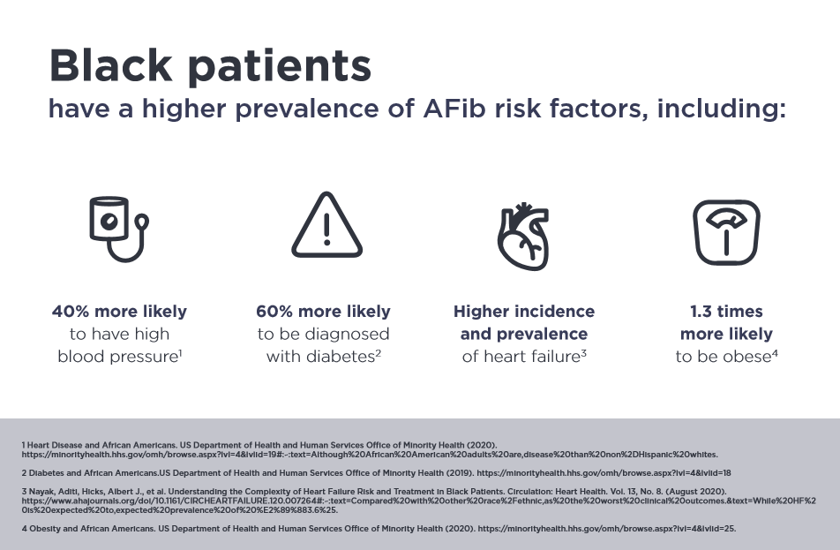
The most common type of treatment for AFib is drug therapy, which includes taking medications to control the heart’s rhythm and rate and/or blood-thinning medication to prevent blood clots from forming and reduce stroke risk. Like nearly half of patients with AFib, [insert patient’s name] still experienced symptoms while taking their medication and wanted something that would help improve their quality of life. That’s when [insert patient’s name] visited Dr. [insert EP’s name], electrophysiologist here at [insert clinic] for the first time.
An electrophysiologist is a cardiologist with extensive training in heart arrhythmias and the electrical activities of the heart. Dr. [Insert Name] specializes in the diagnosis, management and treatment of heart arrhythmias, including catheter ablation. Catheter ablation is a procedure which targets the areas of the heart generating faulty electrical pulses that cause a rapid heartbeat or AFib. By neutralizing and blocking these areas, the pulses are controlled and a normal heartbeat returns. Catheter ablation can improve quality of life and allow patients to get back to doing the things they love.
“[Insert quote from doctor about the importance of diagnosing and treating AFib due to healthcare disparities, and the reason why catheter ablation was the best option]”
For [insert patient’s name], and many others, this procedure has helped them return to normal and improve their quality of life [personalize this, if applicable].
Most patients who receive catheter ablation treatment experience a long-term reduction in both the number of episodes of arrhythmia and the severity of symptoms and many achieve a permanent return to normal heart rhythm. As with any medical treatment, however, catheter ablation has potential risks including bleeding, swelling or bruising at the catheter insertion site, and infection. Serious complications are rare, but can include damage to the heart or blood vessels, blood clots (which may lead to stroke), heart attack, or even death. The success of this procedure depends on many factors, including a person’s physical condition and ability to tolerate the procedure. This is why it’s important for patients to have open discussions with their physicians and carefully select them based on their skill and experience.
“[Insert quote from patient highlighting how the catheter ablation procedure changed their life and why they are glad they sought treatment]”

For more information about AFib, visit GetSmartAboutAFib.com, or visit our website at [insert clinic website].
We will use your information as explained in our Privacy Policy [Insert link].
THERMOCOOL® Navigation Catheters are indicated for the treatment of drug refractory recurrent symptomatic paroxysmal atrial fibrillation, when used with CARTO® 3 Systems (excluding NAVISTAR® RMT THERMOCOOL® Catheter).
The THERMOCOOL® SMARTTOUCH Catheter is indicated for drug refractory recurrent symptomatic persistent atrial fibrillation (AF) (continuous AF > 7 days but < 1 year, refractory or intolerant to at least 1 Class I or III AAD, when used with the CARTO® 3 System.

166182-210202
© Biosense Webster, Inc. 2021

American Heart Association What is Atrial Fibrillation (AFib or AF)? Web Site. https://www.heart.org/en/health-topics/atrial-fibrillation/what-is-atrial-fibrillation-afib-or-af. Accessed July 2019.
Khavjou, Olga, D. Phelps, and A. Leib. “Projections of cardiovascular disease prevalence and costs: 2015–2035.” Dallas: American Heart Association (2016).
Win NT, Shyh PT. Atrial Fibrillation in Older Patients–Reducing Stroke Ris Is Not Only About Anticoagulation. Journal of Geriatric Cardiology (2016) 13: 880-882.
Borovskiy, Yuliya, Killian, Anthony, Levine, Joshua, et al. (2018). African Americans with Atrial Fibrillation at Significantly Higher Risk for Stroke Compared to Caucasians with the Disease. Heart Rhythm.
Graham G. Disparities in cardiovascular disease risk in the United States. Current Cardiology Review. 2015;11(3):238-245. doi:10.2174/1573403x11666141122220003
Graham G. Disparities in cardiovascular disease risk in the United States. Current Cardiology Review. 2015;11(3):238-245. doi:10.2174/1573403x11666141122220003
Calkins H, Reynolds MR, Spector P, et al. Treatment of Atrial Fibrillation With Antiarrhythmic Drugs or Radiofrequency Ablation. Circulation: Arrhythmia and Electrophysiology. 2009;2:349-361.
American Heart Association Ablation for Arrhythmias Web Site. https://www.hert.org/en/health-topics/arrhythmia/prevention--treatment-of-arrhythmia/ablation-for-arrhythmias. Accessed July 2019.
Wilber DJ, Pappone C, Neuzil P et al. Comparison of Antiarrhythmic Drug Therapy and Radiofrequency Catheter Ablation in Patients with Paroxysmal Atrial Fibrillation: A Randomized Controlled Trial. JAMA, 2010.

